

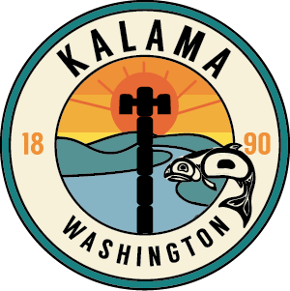

**CITY OF KALAMA PLANNING COMMISSION**

**PUBLIC HEARING**

**KALAMA MUNICIPAL CODE REVISIONS**

**DECEMBER 10, 2020 @ 6pm**

A Public Hearing before the Kalama Planning Commission will beheld Thursday, December 10, 2020 via Zoom for a virtual meeting 6:00 p.m. to take public comment on the Revisions to chapters of the City of Kalama Municipal Code. The purpose of the hearing is to hear public comments on the proposed code revisions. The hearing may be continued without additional publication if time, date and place are announced at this hearing. Those wishing to comment are encouraged to attend and participate at the public hearing via Zoom and access information is available on the City’s website and meeting’s agenda. Written comments may be submitted to PO Box 1007, Kalama, WA 98625 or by email to [cityclerk@kalama.com](mailto:cityclerk@kalama.com). A copy of the proposed code revisions can be picked up at City Hall 195 N. First Street, Kalama or contact City Hall at 360-673-5211

Coni McMaster

Clerk/Treasurer

City of Kalama